Use-Case Realization Report (Requirements)
System Start-Up & Close-Down

Issue 3.0
Revision History
Date | Issue | Description | Author
18 July 2000 | 1.0 | First Issue | Howard Russon
18 July 2001 | 2.0 | Revised for MTech Unit 3 in 2001 | Howard Russon
21 July 2004 | 3.0 | Revised for MTech Unit 3 in 2004 | Howard Russon

Table of Contents
1. Brief Description 4
2. Flow of Events 4
2.1 Standard Flow 4
2.1.1 Begin Simulation 4
2.1.2 End Simulation 4
2.2 Exceptions 4
3. Interaction Diagrams 5
3.1 Domain Collaboration Diagram: System Start-Up & Close-Down 5
4. Participating Objects 5
5. Class Diagrams 7
5.1 Domain Class Diagram: System Start-Up & Close-Down 7
6. Derived Requirements 7

Use-Case Realization Report
System Start-Up & Close-Down

Brief Description
This use case enables the Controller to start-up and close-down the computer simulation of the vending machine. This involves displaying a Simulation Control Panel (when the application is launched). Using the panel, the Controller will be able to start-up the simulation or exit from the application.

Flow of Events
The standard flow of events for this use case and any exceptions are described in the following subsections. See section 3.1 for an overview of the participating Actors and Domain Objects.

Standard Flow
When the application is opened the Simulator Control Panel is displayed. This window is displayed throughout the run of the program. The Controller can then either start-up or close-down the simulation and application as described below.

Begin Simulation
- To start the simulation, the Controller will select the BEGIN SIMULATION button on the Simulator Control Panel. On the real vending machine, this will be achieved by switching-on the power.
- As a result, the configuration information is read from an input file.
- Using the configuration information, details of the drinks brands and coin denominations held by the system are then initialized.

End Simulation
- To terminate the simulation and exit from the application, the Controller will select the END SIMULATION button on the Simulator Control Panel. On the real vending machine this will be achieved by switching-off the power.
- As a result, the main details concerning the drinks brands and coin denominations held in the machine will be determined (ie: the configuration information) and then stored in the input file.
- The user interface panels will then be removed from the screen.
- Control will return to the operating system.

Exceptions
The following exceptions have been identified:
- Input File Not Found (1). If the input file cannot be found during the BEGIN SIMULATION phase, then all the data items will be assumed to be zero.
- Input File Not Found (2). If the input file cannot be found during the END SIMULATION phase, then a new file will be created.

Interaction Diagrams

Domain Collaboration Diagram: System Start-Up & Close-Down
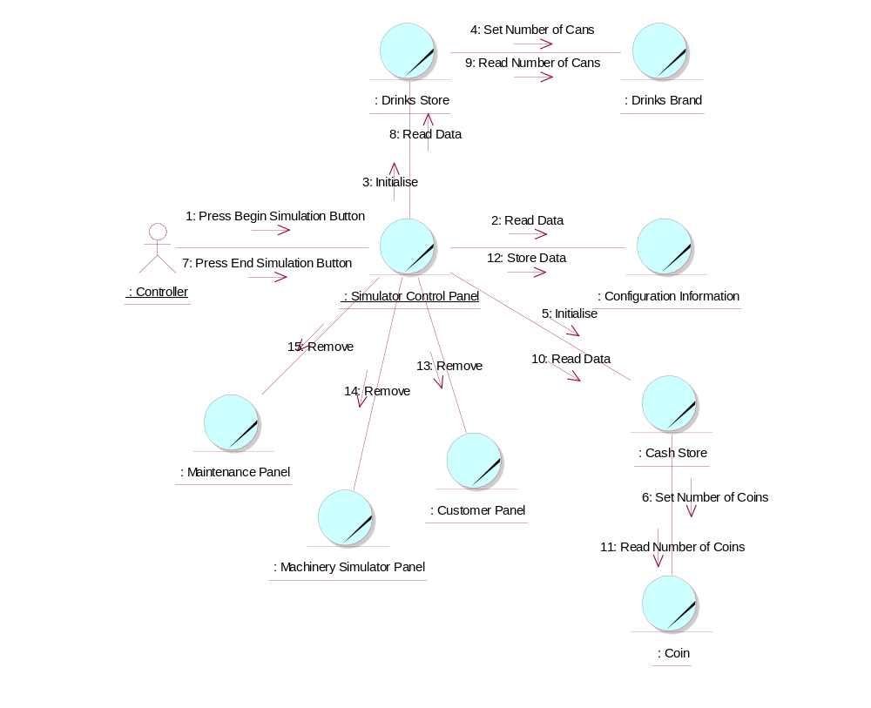

Participating Objects
: Cash Store
This is the repository for all Coins entered into the system. It is also where all change given to the Customer is taken from.
: Coin
The object stores the characteristics of coins entered into the system.
: Configuration Information
This is information defining the basic details concerning the drinks brands and coins, that is read-in from file and used to initialise the simulation.
: Controller
This actor represents the controller of the VMCS simulation. Hence it is only present in the simulated system (ie: this project) and would not be an actor of the target implementation. In particular, it performs several of the physical activities (ie: those that can not be provided by software) that are undertaken by the Maintainer in the target implementation, which include maintaining drink stocks and cash stocks inside the vending machine.
: Customer Panel
This panel simulates the vending machine's customer interface panel. It will enable the user (the Customer) to:
1 insert coins;
2 select brands;
3 terminate transaction.
It will also provide the following display functions:
1 display total money inserted;
2 indicate coin not valid;
3 indicate no change available;
4 display the value of the change to be collected;
5 display an icon representing the dispensed drink.
: Drinks Brand
This object stores the characteristics of the types of drinks can held in the system.
: Drinks Store
This is the repository for the drinks cans held by the system.
: Machinery Simulator Panel
This panel simulates the physical actions of the maintainer. It enables the user to:
1 display and enter new values for the number of cans of each Drinks Brand held by the Drinks Store;
2 display and enter new values for the number of Coins of each denomination held by the Cash Store;
3 display whether the vending machine Door is unlocked, and enable it to be locked.

: Maintenance Panel
This panel simulates the vending machines maintainer control panel. It will enable the user (the Maintainer) to:
1 log-on using a password;
2 display number of Coins of each denomination in the Cash Store;
3 display total value of cash in the system;
4 display number cans of each Drinks Brand held in the Drinks Store;
5 change the price of any Drinks Brand;
6 collect all cash held in system;
7 formally exit from the panel.
: Simulator Control Panel
This panel is displayed when the system is started up. It enables the user (the Controller) to :
1 start (switch on);
2 stop (switch off);
3 activate the customer panel;
4 activiate the maintenance panel;
5 activate the machinery simulator panel.

Class Diagrams

Domain Class Diagram: System Start-Up & Close-Down
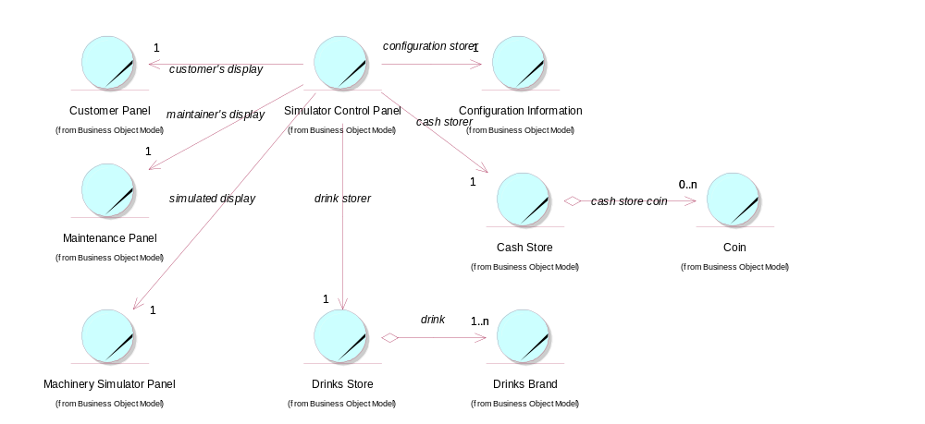

Derived Requirements
The Simulator Control Panel should have the format specified in figure 2 of "User Requirements Specification for Vending Machine Control System (VMCS) Computer Simulation", reference ISS/VMCS/TR.1

